

**Rafael Lopez**

**About**:

Rafael Lopez is a Mexican artist/illustrator who has illustrated various children's books and painted several murals. His goal is to bring diversity into children's books by including young characters with different skin colors, hair textures, and backgrounds. His book illustrations have gained him several awards including Silver Metal from the Society of Illustrators, Jane Adams Children’s Book Award, National Cartoonist Society Book Illustration Award, and New York Times #1 Children’s Book Bestseller. The murals he creates also bring people together. He allows people in the community and children to help paint parts of the murals as a way to collaborate and bond with one another.

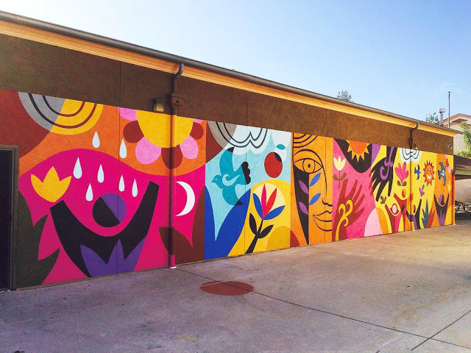

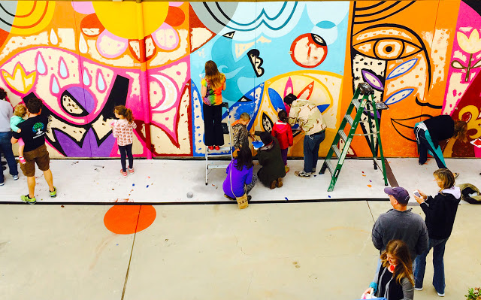

Rafael Lopez**,** *Maybe Something Beautiful***,** 2016

**Learning Targets for the Day:**

* Children will learn about and discuss Rafael Lopez and his artwork
* Children will analyze how he portrays friendship and relationships in his works
* The class will read a story illustrated by Rafael Lopez
* Children will learn about collaboration and build a garland together to practice collaborating with their peers

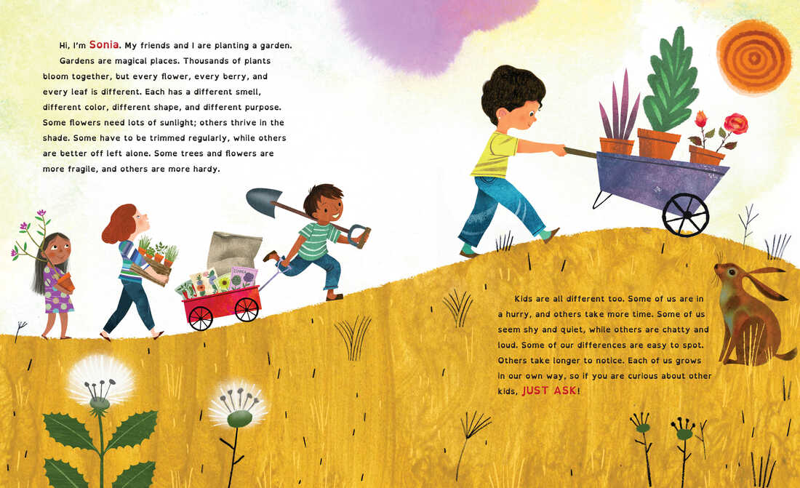

Rafael Lopez, *Just Ask*, 2019

**Vocabulary**:

**Collaboration**- working together as a team

**Friends**- a person you can have fun with & trust

**Garland**- a hanging decoration made out of different objects

**Illustrator**- a person who draws pictures for books

**Questions**:

**Artist**: How do you think Rafael Lopez’s murals are connected to friendship?

**Artwork**: What do you notice about the colors Rafael uses in his art? Do the children in his illustrations all look the same?

**World**: How does collaboration make Rafael’s mural more meaningful to others in the world?

**Audience**: What do you think others feel when they look at Rafael’s Work? What do you feel when you look at his work?